Dayne Longtin

Prof. Manprisio

CPSC-4535

8 August 2019

Intro to Unix: Final Lab

Part #1:

d.

Screenshot #1:

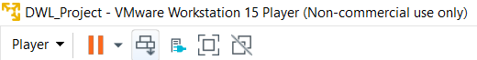

This is the section of the lab where I created the VM and named it accordingly.

Part #2:

1. I’ve never been the most experienced with Linux based technology, but there are definite similarities between Windows OS and Ubuntu OS. Similar to the start button in Windows there is show applications button and it displays a list of applications you may utilize in the OS. Similar to MS Word, there is also a Libre application that enables to user to type and create documents. There is also a Linux edition of Visual Studio giving you access to developing programs. I think another similarity between Windows and Ubuntu being that there are “desktop” icons in Ubuntu for priority usage over other applications.
2. Initially when I was downloading Ubuntu software I thought it was going to be another really ugly looking operating system to work on. In other classes I have taken gave me really awful operating systems to work with. Sadly I don’t explicitly remember the names of them. They very well could have been much older versions of Ubuntu, but I remember getting exceedingly frustrated with them. Mainly because the GUI was awful. I couldn’t locate anything, everything was archaic; albeit it was really cool to learn how to do everything manually. Back on the topic of this OS, when I opened this OS up it was gorgeous. Everything about it was so pretty; everything is very well laid out, I have no troubles finding what I need to get. It’s also incredibly distinct and colorful. As silly as it sounds, if a GUI is makes good use of color and doesn’t have a cluttered design I will be very happy.
3. I know this correlates to the relation of Ubuntu and Android, but I am going to refer back to question a to answer this question. This OS does remind me of Windows with its show applications function, but now that I think about it. It reminds me much more of an Android OS and how its applications window works. When I go into my android phone, I can do a general swipe up and every application on the entire system will show up. Very similar in that aspect as well as how the application icons look. Many of the icons be it that they are not a 1 to 1 in similarity border identical to most android applications.

Part #3:

1. Chmod: I think this command is vital in Linux because it contains permissions as to who can access and edit files. Especially in a workplace setting, this is absolutely a command all Linux users should know.
2. Df: I think this is a basic, but great command to use just to ensure that users have enough space on their filesystems and it’s just a great command to be able to check space and see where the system is at.
3. Echo: It’s just a simple command all users should know in order to print text.
4. Exit: It’s a great general command in order to close out of anything in the shell. If a user isn’t sure how to get out of something, exit is usually a great command to use to test in order to leave a program.
5. Gzip: I’m a big fan of compressing/zipping files on my own computer. This is a fundamental command most Linux users should know if they want to compress a file.
6. Ls: Arguably one of the most important commands. This command looks for files in a given directory. It’s most definitely a command all Linux users should know.
7. Mkdir: This is a command every Linux user should know because it’s responsible for creating new file directories.
8. Mv: If users want to move files to different directories. This is a command essential to those users because it is responsible for that.
9. Ps: This command is extremely important because it lists current processes running in the shell. If Linux users would like to see everything running, this is the command users should take advantage of.
10. Head: This is a great command as it will list the first 10 lines of a file. Users can also modify the command to see less lines if they would like.

Part #4:

1. The applications I have opened that run both music and videos on Ubuntu would be that of the Videos application and the Rythmbox application.
2. Both applications are interesting as they remind me of a blend of both Apple and MS applications. Here’s why, in a simple fashion both apps remind me of Apple based technology because they layout of the visual representation reminds me of them. Linux based applications having a much more rounded out look similar to Apple, rather than angular like Microsoft applications. To be honest the Videos applications doesn’t particularly remind me of anything that Microsoft would put out, it reminds me of YouTube somewhat in terns of its functionality. It basically hosts several pages to look at trailers and such. Now in terms of how Rythmbox works, it reminds me a lot of Windows Media Player due to the fact that the menu layout is incredibly similar tabs for different functions in the application. There are similarities between the Rythmbox application and Windows in terms of how they work, but visually the look quite dissimilar.

Part #5:

1. I could immediately tell the differences between the Linux file system and the Windows file system. I have played with Linux before using Virtual Box, but I never really paid attention to the file organization. Paying attention to it, it is definitely designed to be very user friendly. There is not only a dropdown menu for all of the file destinations, but there are also identical folders laid out to the right in order to aid people who need a visual reference to know where things are at. I also really like that the Linux file distribution is designed with the video file destination and the picture file destination being separate from each other. Another interesting difference being that the trash bin is in the file system as compared to Windows having their trash bin on the desktop.
2. Although there are the differences I listed from above, there are more similarities between them than differences. I think overall the recent tab, and the entire dropdown menu is practically identical to Windows file explorer. The file organization is almost identical with the tabs showing where each previous file destination tab led to and the back tab that allows the user to retrace their steps. It’s very much an MS inspired file organization system.

Part #6:

a.

Screenshot #2:

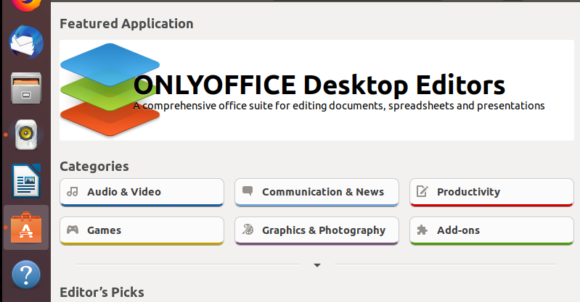

This is the section of the lab where I displayed that I had the Ubuntu app store up and running.

c.

Screenshot #3:

This is the section of the lab where I downloaded 2 applications being simple games. (I didn’t want to download anything that would make my computer freeze on me.) Both of which are running on my Ubuntu OS.

d. I definitely like the layout of everything in the Ubuntu app store. I really like that rather than having garbage hyperlinks for everything there are actual boxes to bring you to additional content with good use of CSS. I like the simplicity of this OS, I know I overuse that term, but really. Especially with this application. Everything is extremely easy to locate and install with no hitches in the process.

Part #7:

Screenshot #4:

This is the part of the lab where I showed the IP address configuration settings. That being my IPv4 address, my IPv6 address and my MAC address.